**CIRCLECI DOCUMENTATION**

**What is Continues Integration?**

Continuous Integration (CI) is a development practice that requires developers to integrate code into a shared repository (i.e. Github, SVN) several times a day. Each check-in is then verified by an automated build, allowing teams to detect problems early.   
  
By integrating regularly, we can detect errors quickly, and locate them more easily.

**Continuous Integration brings multiple benefits to our organization:**

* Say goodbye to long and tense integrations
* Increase visibility enabling greater communication
* Catch issues early and nip them in the bud
* Spend less time debugging and more time adding features
* Build a solid foundation
* Stop waiting to find out if your code’s going to work
* Reduce integration problems allowing you to deliver software more rapidly

**What is Circle CI?**

**CircleCI's** continuous integration and delivery platform makes it easy for teams of all sizes to rapidly build and release quality software at scale. Build for Linux, macOS, and Android, in the cloud or behind your firewall.

It will automatically run a series of steps every time that it detects a change to our repository. A **CircleCI** build consists of a series of steps.

**Benefits of Circle CI**

* Build Isolation

## Developer-Driven Configuration

## Fast Builds

## Broad, Extensible Coverage

## GitHub Friendly

## Knowledgeable Support

**CircleCI** vs **Jenkins**

When comparing **CircleCI** vs **Jenkins**, the Slant community recommends **CircleCI** for most people. In the question **“What are the best continuous integration tools?”** **CircleCI** is ranked 2nd while **Jenkins** is ranked 4th.

The most important reason people chose **CircleCI** is:

Tests can be parallelized across multiple machines reducing test times drastically. They support up to 8-way parallelization. Additionally, CircleCI caches the build environment.

**Workflow of Circle CI:**

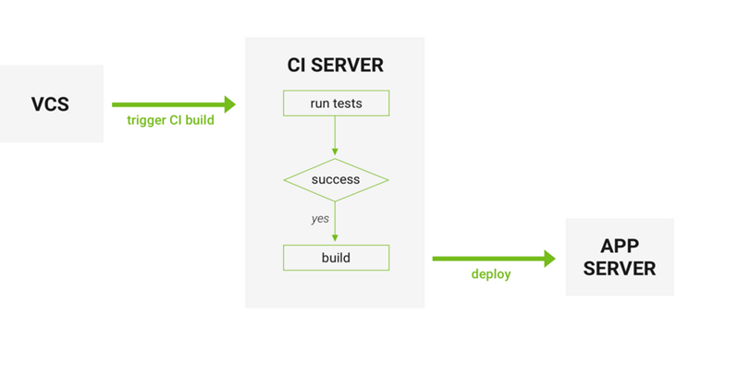

**Demo:**

Step 1: Signup using github or Bitbucket

Step 2: To add your new repo, ensure that your GitHub account is selected in the dropdown in the upper-left, find the repository you just created below, and click the **Setup project** button next to it.

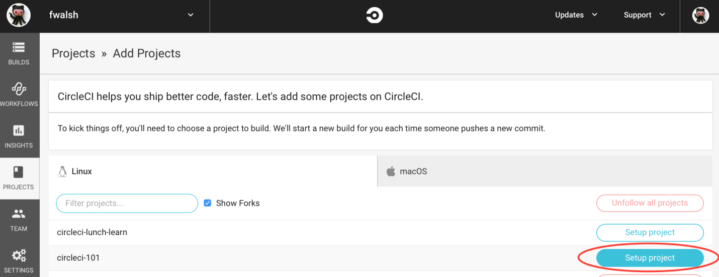

Step 3: On the next screen, you’re given some options for configuring your project on CircleCI. Leave everything as-is for now and just click the **Start building** button a bit down the page on the right.

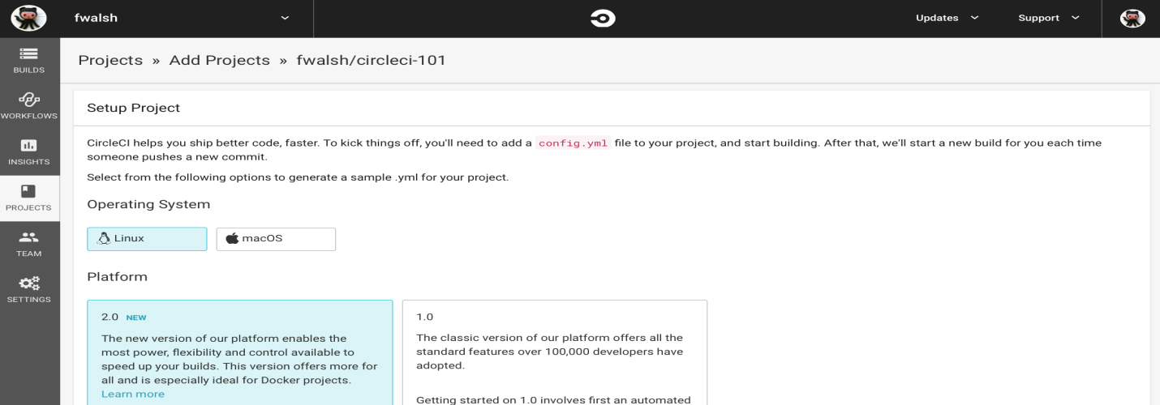

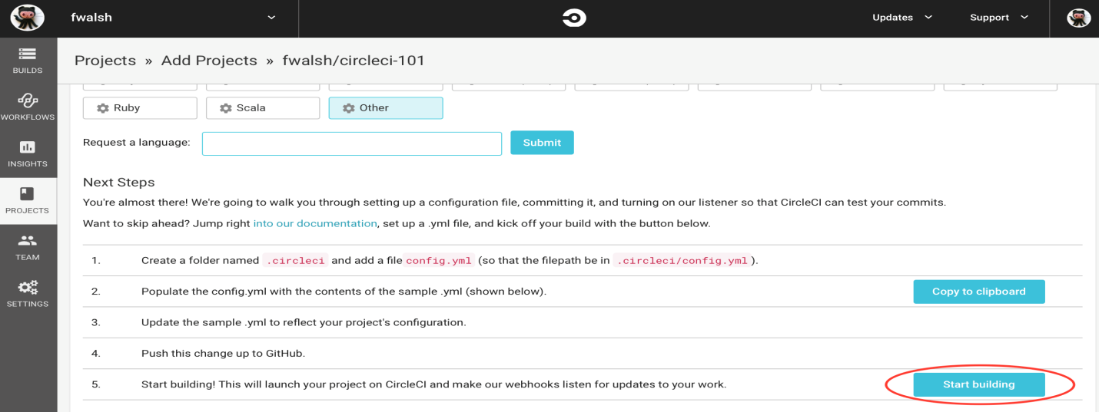

**Result:**

